050912_001C Assembly Drawing – PCB Dimensions: 3.409” x 0.721”

11/11/16

TOP

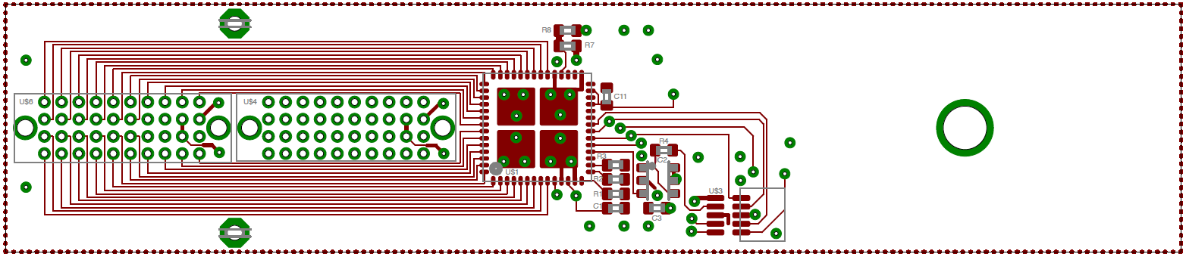

Top - Zoomed

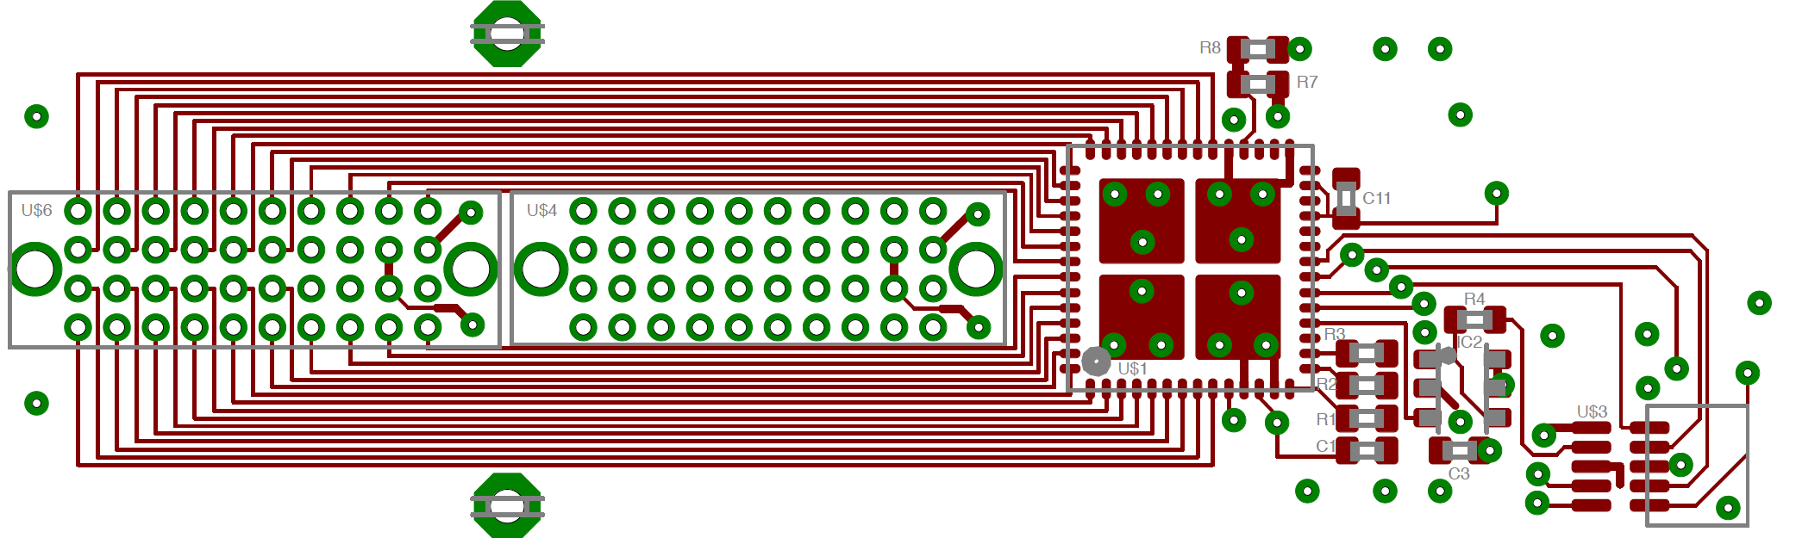

050912_001C Assembly Drawing

Bottom

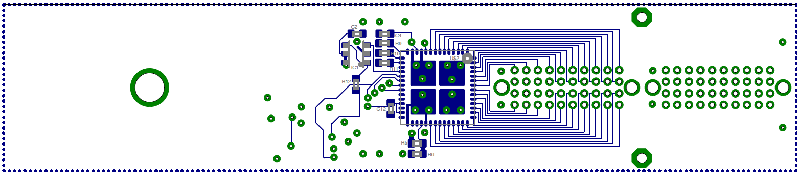

Bottom - Zoomed

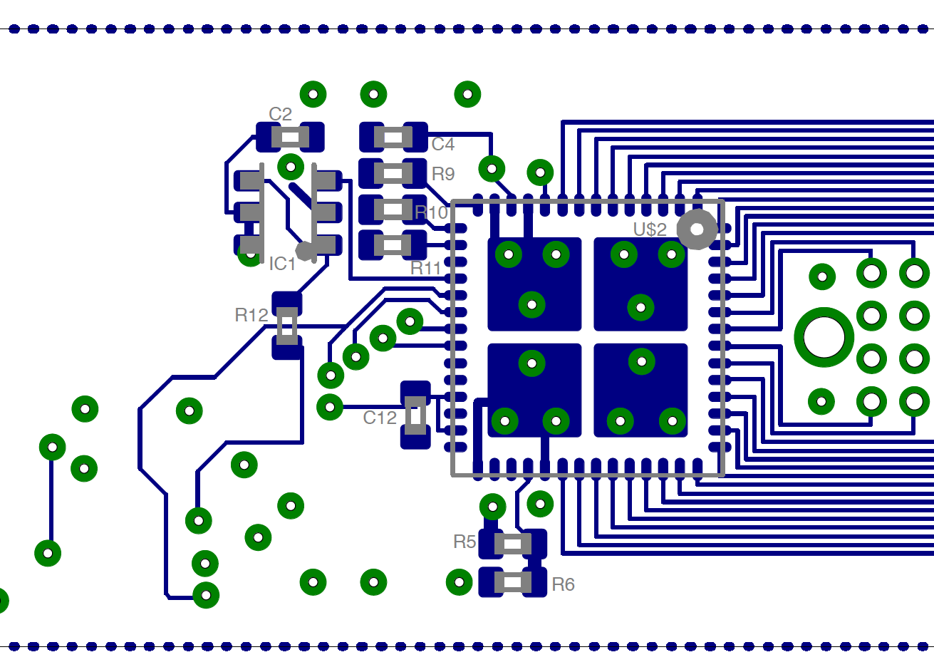

TOP Side – correct orientation of connectors

